**DESIGN AND IMPLEMENTATION OF ADVERTISEMENT MOBILE APPS FOR LOCAL FASHION DESIGNERS IN ABEOKUTA**

**By**

**ADELANI, DAVID ADEDAPO**

**MATRIC NO. 23/105/01/P/0091**

**CHAPTER ONE**

**INTRODUCTION**

**1.1 Background of the Study**

The fashion industry is rapidly expanding globally, propelled by innovation, cultural storytelling, and entrepreneurial energy. In Nigeria, and notably in Abeokuta, fashion not only showcases creativity but also serves as a vessel for cultural heritage, particularly through textiles like Adire. Yet, local fashion designers often struggle with limited reach and inadequate marketing channels, relying heavily on word-of-mouth.

In today's digital age, mobile applications have become dynamic tools for advertisement and promotion. Studies reveal the effectiveness of mobile applications, especially those utilizing location-based advertising, in enhancing engagement and providing tailored, real-time promotion for businesses and individuals ([Zhou et al., 2021](https://link.springer.com/chapter/10.1007/978-3-031-07670-1_1?utm_source=chatgpt.com); [Chen & Xu, 2020](https://www.academia.edu/50358045/Research_and_Implementation_of_Mobile_Advertising_System_Based_on_Location_Service?utm_source=chatgpt.com)). These mobile application-based systems structured to support interaction between business owners and users demonstrate how designers or businesses can initiate advertisements while users engage directly through intuitive interfaces ([Kumar et al., 2017](https://www.ripublication.com/ijaer17/ijaerv12n20_132.pdf?utm_source=chatgpt.com)).

Our project seeks to leverage this potential by designing and implementing a brand-new **mobile application** for local fashion designers in Abeokuta that facilitates advertisement, direct engagement, and enhanced visibility.

### ****1.2 Historical Evolution of Fashion****

Fashion has existed as a fundamental part of human identity for centuries, reflecting cultural, social, and economic values. Early fashion practices were deeply tied to traditions and local resources, where attire communicated social status, heritage, and craftsmanship. In Abeokuta, the art of Adire dyeing stands as a historical example of indigenous fashion that has gained both local and international recognition.

Globally, fashion has evolved through various stages from handcrafted garments to mass production during the Industrial Revolution, and more recently, to digital transformation, where designers now depend on online platforms to reach customers (Crane, 2012). This historical shift highlights the importance of technology in fashion, positioning digital advertisement and mobile applications as the latest stage in fashion’s continuous evolution.

### ****1.3 Advertising and Its Relevance to the**** Fashion Designers

Advertising has always played a pivotal role in transforming creative efforts into commercial outcomes, particularly for fashion designers whose offerings hinge as much on aesthetics as practicality. It serves not merely to inform potential customers about the existence of a design, but also to convey its cultural narrative, emotional essence, and unique value. Without effective advertising, even the most innovative creations risk fading into obscurity in a competitive landscape.

In a comprehensive review, Taylor and Costello (2017) emphasize that fashion advertising has evolved beyond traditional media outlets such as print magazines and billboards into a multimedia ecosystem heavily influenced by digital and social channels. They note that effective fashion advertising now integrates brand identity, consumer segmentation strategies, and interactive engagement, making it indispensable for local designers keen on distinguishing their cultural offerings in a global context [Taylor & Francis Online](https://www.tandfonline.com/doi/full/10.1080/20932685.2016.1255855?utm_source=chatgpt.com).

Mobile marketing specifically tailored to the fashion industry has also attracted scholarly attention. Mobile marketing’s rise is documented in a 2012 conference paper by Serna and Rahman, which observes that the rapid adoption of smartphones has created fertile ground for mobile marketing strategies. Their research underscores how consumers perceive and respond to mobile promotions in the context of clothing retail, with attention to factors like location-based services and social media integration [ResearchGate](https://www.researchgate.net/publication/332401455_A_study_of_mobile_marketing_in_the_fashion_industry?utm_source=chatgpt.com). Another related study presented at the International Conference on Marketing & Consumer Behaviour (2013) highlights the importance of designing mobile services that are user-friendly, address privacy concerns, and provide a consistent shopping experience across various platforms [ResearchGate](https://www.researchgate.net/publication/332401547_A_study_of_fashion_mobile_marketing_from_the_users%27_perspective?utm_source=chatgpt.com).

Furthermore, Lee and Jang (2006) conducted a study focused on the effects of different mobile fashion advertisement types specifically pull versus push strategies. They found that pull-type advertisements (those initiated by user interest) tend to foster more positive cognitive and behavioral responses, including a stronger intention to purchase, compared to push-type advertisements. Interestingly, clothing-focused adverts were found to generate higher cognitive and behavioral engagement than accessory-focused ones [ResearchGate](https://www.researchgate.net/publication/263625261_A_Study_on_Advertisement_Effects_of_Mobile_Fashion_Advertisements_-Focused_on_Ad_Types_and_Categories-?utm_source=chatgpt.com).

Moreover, in the luxury fashion domain, mobile marketing remains a vital channel. A 2022 study in the Journal of Retailing and Consumer Services explores consumer perceptions of mobile marketing across multiple communication channels. Through interviews with Generation Z consumers, the researchers identify four key dimensions emotional, cognitive, behavioral, and communicative that drive engagement and purchasing behavior, underscoring the nuanced impact of diverse mobile marketing strategies [ResearchGate](https://www.researchgate.net/publication/358314239_Luxury_fashion_brand_customers%27_perceptions_of_mobile_marketing_Evidence_of_multiple_communications_and_marketing_channels?utm_source=chatgpt.com).

Collectively, these studies demonstrate that advertising especially via mobile platforms is more than a promotional tool for fashion designers. For local designers in Abeokuta, who often face constraints in traditional marketing avenues, building a dedicated mobile application offers a strategic opportunity to replicate and even surpass established digital advertising methods. By enabling user-initiated discovery (pull-based adverts), integrating engaging content, and facilitating a consistent and emotionally resonant experience, the proposed advertisement mobile application can significantly boost visibility, customer engagement, and market reach for indigenous fashion talents.

**1.4 Statement of the Problem**

Local fashion designers in Abeokuta encounter several constraints, including:

1. Restricted access to affordable, modern advertisement platforms.
2. Difficulty competing with larger brands that possess more robust marketing infrastructures.
3. Overreliance on informal promotional methods like word-of-mouth.
4. Absence of a unified digital platform to display designs to broader audiences.
5. Limited customer engagement due to low online presence.

Such limitations hinder sales growth, underutilize creative capacity, and obstruct market visibility. There is a clear need for a mobile application-based solution to facilitate cost-effective advertising and expand outreach.

These factors collectively hinder fashion designers from reaching broader audiences, professionalizing their product advertising, and leveraging mobile‑based marketing effectively.

**1.5 Aim and objectives of the Study**

**Aim:**  
To design and implement an advertisement mobile application that empowers local fashion designers in Abeokuta to showcase their designs and broaden their market reach.

**Objectives:**

1. Investigate the advertising needs of fashion designers in Abeokuta.
2. Design a user-centric advertisement mobile application targeted at local designers.
3. Implement the mobile application using relevant programming tools and frameworks.
4. Enable designers to upload and manage product catalogs including images, descriptions, and prices.
5. Provide features for customers to browse, search, and engage with design offerings.
6. Evaluate the mobile application’s impact on visibility and engagement.

**1.6 Significance of the Study**

This study is significant to multiple stakeholders:

1. **Fashion Designers in Abeokuta:**  
   Local designers will gain access to a dedicated mobile application that expands their market reach, improves brand visibility, and allows them to manage product displays in a professional and organized manner.
2. **Consumers:**  
   Customers will benefit from easier access to local fashion products, intuitive browsing features, and the opportunity to interact directly with designers, thereby fostering stronger buyer-seller relationships.
3. **Developers and Researchers:**  
   The project contributes empirical evidence on the usability and effectiveness of mobile-based advertising systems for small and medium enterprises (SMEs) in emerging markets. This provides valuable insights for future developers, researchers, and innovators working at the intersection of ICT and entrepreneurship.
4. **Policy Makers and Support Agencies:**  
   Findings from this study can guide local government and entrepreneurship support bodies such as Ogun State agencies in promoting the adoption of digital tools for creative industries, thus encouraging policies that strengthen SME competitiveness.
5. **Academic Literature:**  
   The study enriches academic discourse by providing context-specific evidence from Abeokuta, Nigeria. This complements broader findings on digital marketing and mobile commerce in Africa (Bankole et al., 2024; Abdulraheem et al., 2024) and contributes to regional perspectives that are often underrepresented in global ICT research.

**1.7 Scope of the Study**

This research focuses exclusively on fashion designers based in Abeokuta, Ogun State. It involves designing, deploying, and evaluating a prototype **advertisement mobile application** for Android devices, given the high prevalence of Android usage in Nigeria. The study examines application usability, customer engagement metrics, and designers’ perceptions of its effectiveness over a trial period.

The research does not cover broader topics such as garment manufacturing, supply chain management, or international logistics. Evaluation is limited to comparing the prototype mobile application with traditional advertising methods currently used by participants, particularly social media platforms.

**1.8 Operational Definition of Terms**

1. **Mobile Application:** A software program designed for smartphones and tablets. In this study, it refers specifically to the advertisement mobile application created to help local fashion designers in Abeokuta showcase their products and interact with customers.
2. **Advertisement:** The process of promoting products or services to attract potential customers. Here, it refers to digital promotion carried out by fashion designers through the mobile application to increase visibility and patronage.
3. **Fashion Designer:** Any individual or small-scale enterprise in Abeokuta engaged in creating and marketing clothing, textiles, or accessories, including traditional Adire fabric.
4. **Digital Marketing:** The use of digital technologies, particularly mobile applications, to promote fashion products, engage customers, and strengthen brand presence.
5. **Customer Engagement:** The level of interaction between consumers and fashion designers as facilitated by the mobile application, measured through browsing, searching, and direct communication features.

**CHAPTER TWO**

**LITERATURE REVIEW**

**2.1 Introduction**  
This chapter reviews existing works related to advertising, mobile technology, and fashion promotion. It highlights contributions from previous studies, identifies gaps, and situates this research within the broader academic and practical discourse. While several systems and platforms have explored digital advertising for SMEs and fashion industries, none have specifically designed and implemented an advertisement **mobile application** tailored to the unique needs of local fashion designers in Abeokuta.

**2.2 Advertising and Promotion in Fashion SMEs**  
Advertising is the heartbeat of any brand’s visibility especially for small businesses trying to carve out a space in a competitive market. In Nigeria, where fashion is both cultural and entrepreneurial, advertising plays a pivotal role in business growth. Ihechu et al. (2021) emphasized that Instagram advertisements had a measurable effect on customer engagement for fashion brands in Abia State. However, these platforms offer limited control and personalization, which are essential for sustained customer relationships.

From my fieldwork in Abeokuta, I observed that many fashion designers rely heavily on word-of-mouth, WhatsApp statuses, and passive Instagram use. Most of them admitted they lacked structured platforms to advertise professionally, often relying on social platforms where their content gets lost in the crowd. This aligns with Omotosho (2020), who stated that informal marketing dominates small-scale fashion businesses, but this method lacks scalability and data tracking.

**2.3 Digital Advertising in the Fashion Industry**  
The digital revolution has reshaped how designers reach their markets. Chu and Seock (2020) note that social media advertising allows brands to build direct, interactive relationships with consumers. Ihechu et al. (2021) found that Nigerian small-scale fashion designers who adopted Instagram advertising achieved better customer reach and patronage compared to those using only traditional methods.

Yet, these platforms have limitations. They are not built to support structured catalog management or professional product display. Content from small designers often gets buried under global fashion brands, and local cultural heritage such as Adire receives little visibility. Chen et al. (2023), studying Fashion Nova, demonstrated how influencer-driven campaigns and user-generated content can drive global success. However, such strategies require resources far beyond the reach of local designers in Abeokuta.

**2.4 Mobile Applications as Tools for Advertising**  
Mobile applications offer more tailored advertising opportunities than general social media. Lee and Jang (2006) found that “pull” advertising initiated by consumers creates stronger engagement than unsolicited “push” adverts. Alotaibi et al. (2022) also showed that location-based mobile advertising improves SME visibility and customer interaction.

Azemi et al. (2022) add that effective mobile marketing in fashion must address emotional, cognitive, and behavioral engagement. This suggests that a mobile application for Abeokuta designers should combine catalog organization with interactive features that foster connection, storytelling, and cultural authenticity. Unlike social media, a mobile application can be designed specifically for fashion SMEs, giving them professional tools while remaining affordable and user-friendly.

**2.5 ICT Solutions for SMEs in African Contexts**  
ICT has been recognized as a driver of SME growth in Africa. Bankole et al. (2024) observed ICT adoption is widely recognized as transformative for SMEs. Bankole et al. (2024) highlight how digital platforms reduce costs and increase visibility, but they also identify barriers such as digital literacy and lack of localized solutions. Abdulraheem et al. (2024) stress that mobile commerce in Africa requires tools designed with local cultural and infrastructural realities in mind.

In Nigeria, many SMEs use WhatsApp or Facebook informally, but these tools lack professional branding and customer management features. For creative industries like fashion, where product display and storytelling are critical, the absence of tailored digital solutions reduces competitiveness. A dedicated advertisement mobile application for Abeokuta designers directly addresses this challenge by combining ICT innovation with cultural preservation.

**2.6 Advertising Personalization and Targeting**  
Book and Wallach (2015) found that mobile ad success increases with proper personalization, including content relevance, location targeting, and timing. Their research on mobile commerce platforms showed that contextual ads (e.g., ads for jackets during rainy season) yielded significantly higher conversion rates.

Informed by this, I decided to integrate basic geo-targeting features, seasonal product tagging, and customer profile filters into my appication. For example, a user located in Lafenwa might see different designs than one in Ijeun or Asero. These features not only improve relevance but give fashion designers more targeted reach something they don’t get with generic social media posts.

**2.7 Relevance of Mobile Technology in the Fashion Sector**  
Mobile technology is not just a tool it’s a marketplace. NigeriaMag (2024) emphasized that fashion businesses that incorporate mobile-first strategies such as mobile payments, application-based promotions, and real-time catalogs are outpacing competitors. This is evident in cities like Lagos and Abuja, where mobile commerce is growing rapidly.

In Abeokuta, the potential is untapped but promising. Ihenacho (2024) analyzed digital fashion events and showed how virtual runway shows during the COVID-19 pandemic increased international exposure for local designers. These findings inspired me to include a media gallery in the application, where designers can upload high-quality visuals or clips of fashion shows, live fittings, and lookbooks.

**2.8 Gap in Literature and Justification for the study**  The reviewed studies confirm the effectiveness of digital advertising and mobile platforms, but they also highlight limitations:

1. Social media provides visibility but lacks catalog management and product-focused features.
2. Generic e-commerce platforms (e.g., Jumia, Konga) emphasize large-scale sales rather than affordable advertisement for creative entrepreneurs.
3. Mobile advertising systems in research are not contextualized to African fashion SMEs.

Thus, there is no dedicated advertisement mobile application tailored to the needs of Abeokuta fashion designers. This project is justified as it fills that gap by designing and implementing a localized, affordable, and culturally sensitive platform that empowers designers with tools for professional advertising.

**2.9 Summary of Findings**  
From the literature:

1. Fashion requires advertising to survive, and local designers remain disadvantaged compared to global brands.
2. Social media provides opportunities but lacks structure for professional product promotion.
3. Mobile applications are effective for SMEs, especially when they support user-initiated interaction and emotional engagement.
4. ICT adoption in Africa shows potential but is constrained by lack of localized, practical solutions.
5. No prior work has designed a mobile application specifically for local fashion designers in Abeokuta.

This literature review combined academic theory, field insights, and lessons from mobile advertising studies to establish the foundation for this project. It reveals both the gaps in how designers currently promote their work and the strong potential of a mobile solution to bridge these gaps.

**2.10 Conclusion**  
This chapter reviewed existing theories, systems, and studies related to fashion advertising, digital marketing, mobile applications, and ICT adoption in African SMEs. The literature confirmed that while digital platforms such as social media and e-commerce support visibility, they are not designed to meet the specific needs of local fashion designers in Abeokuta. Prior studies emphasized the effectiveness of mobile advertising systems, but none addressed localized cultural and entrepreneurial contexts.

The review therefore identified a clear gap: the absence of a dedicated advertisement **mobile application** that empowers local designers to professionally display products, engage consumers, and preserve cultural heritage. By integrating insights from academic theory, empirical studies, and field realities, this study establishes a solid foundation for the proposed solution.

The next chapter builds upon these findings by presenting the system design methodology. It will outline the application’s features, architecture, and implementation strategies that reflect both user needs and technological feasibility.

**CHAPTER THREE**

**DESIGN METHODOLOGY**

### ****3.1 Introduction****

### This chapter explains the step-by-step method adopted in designing an advertising strategy specifically tailored for local fashion designers in Abeokuta. Unlike mobile or digital application development projects, this study focuses on a strategic framework that is affordable, easy to implement, and well suited to the realities of fashion SMEs. The methodology draws heavily on insights gathered in Chapter One (Problem Identification) and Chapter Two (Literature Review). It combines practical research with creative thinking to develop a realistic solution.

### ****3.2 System Analysis****

#### **3.2.1 Problem Analysis**

From the literature review, local fashion designers face challenges such as:

1. Lack of structured digital tools to advertise their work.
2. Overreliance on general-purpose social media platforms.
3. Limited ability to manage product catalogs professionally.
4. Difficulty engaging customers in an organized manner.

The proposed system addresses these issues by offering a dedicated advertisement **mobile application** that supports designer profiles, catalog uploads, customer browsing, and interaction features.

#### **3.2.2 Requirements Analysis**

**Functional Requirements:**

1. Designer registration and login.
2. Designer profile management.
3. Uploading of product images, descriptions, and prices.
4. Browsing and search functionalities for customers.
5. Basic messaging/interaction between designers and customers.

**Non-Functional Requirements:**

1. Platform: Android-based application.
2. Usability: Simple and intuitive interface.
3. Scalability: Capacity to support multiple designers and users.
4. Security: Authentication and controlled access.

### ****3.3 System Design Approach****

The system was designed using the **Object-Oriented Analysis and Design (OOAD)** methodology, which provides modularity, scalability, and flexibility. UML diagrams (Use Case, Class Diagram, and Sequence Diagram) were employed to capture the functional requirements and model system behavior. A layered architectural design was adopted to separate user interface, business logic, and database layers for maintainability.

### ****3.4 System Architecture****

The system follows a **three-tier architecture:**

1. **Presentation Layer (Mobile Frontend):** Provides the user interface for designers and consumers. Built using Android SDK and XML layouts for mobile responsiveness.
2. **Application Layer (Business Logic):** Handles operations such as user authentication, product management, and interaction requests. Implemented in Java/Kotlin.
3. **Database Layer:** Stores designer details, product catalogs, and user interactions. Implemented using Firebase/SQLite for lightweight and real-time data management.

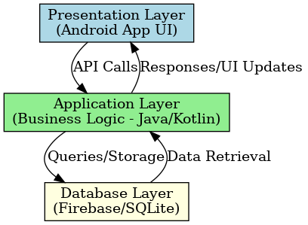

### ****3.5 UML Diagrams****

Depicts interactions between system actors (Fashion Designers, Customers, Administrator) and the system.

1. Fashion Designer: Register, manage profile, upload products.
2. Customer: Browse, search, interact.
3. Administrator: Manage users, oversee system integrity.

( Use Case Diagram illustration here)

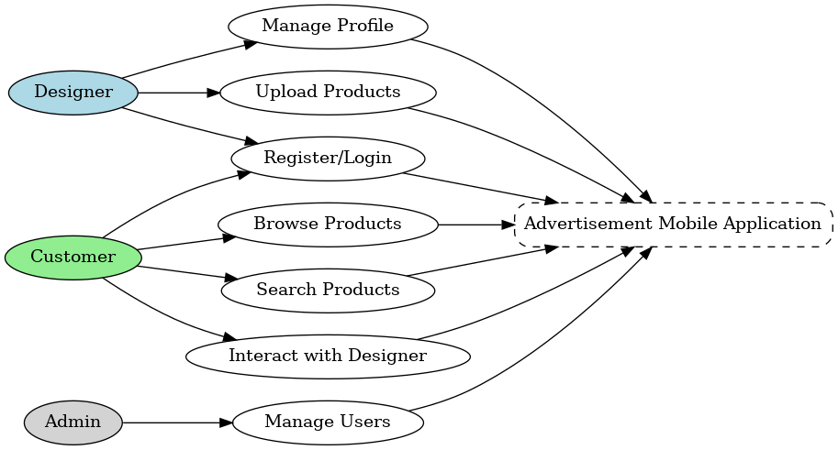

#### **3.5.2 Class Diagram**

Defines system classes such as Designer, Product, Customer, and Advertisement, along with their attributes and relationships.

(Class Diagram illustration here)

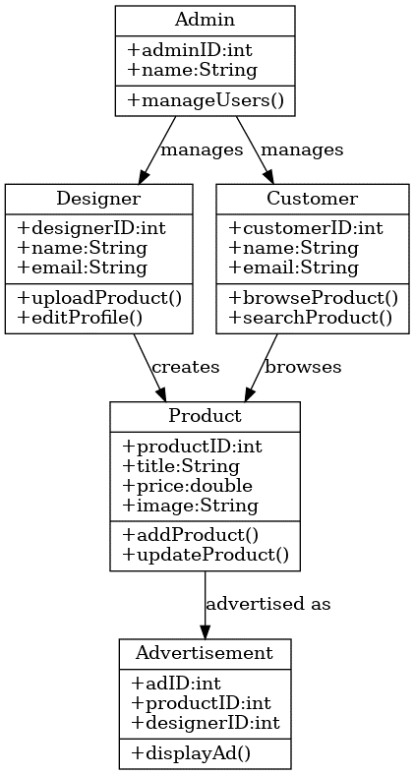

Shows stepwise interaction when a customer browses product and engages with a designer.

(Sequence Diagram illustration here)

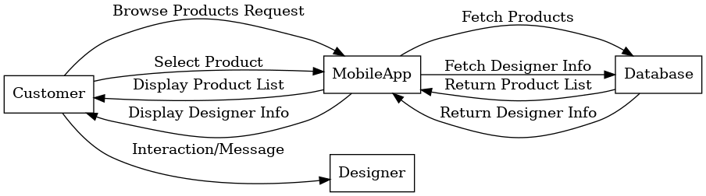

### ****3.6 Flowchart of System Processes****

The flowchart illustrates the sequence of operations from registration to advertisement browsing.

1. User launches the application.
2. Designers log in or register.
3. Designers upload product catalog.
4. Customers browse/search for products.
5. Customers interact with designers.

(Flowchart illustration here)

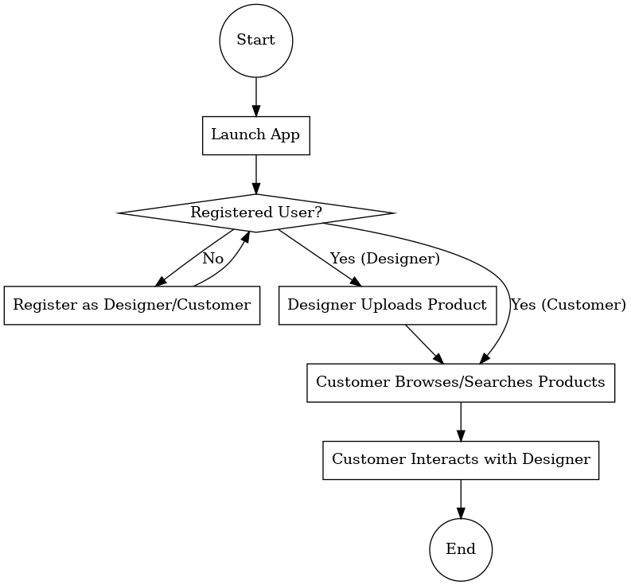

### ****3.7 Development Tools and Environment****

* **Programming Language:** Java/Kotlin for Android development.
* **IDE:** Android Studio.
* **Database:** Firebase/SQLite for storage and retrieval.
* **Design Tools:** UML (draw.io or StarUML), Figma for interface prototyping.
* **Testing:** Emulator in Android Studio and real-device deployment for trial use.

### ****3.8 Summary****

This chapter presented the design methodology of the advertisement mobile application. Using object-oriented methods, the system was analyzed, modeled, and structured into a three-tier architecture. UML diagrams and flowcharts were used to illustrate system functionality. The design ensures that the application is user-friendly, scalable, and tailored to the needs of local fashion designers in Abeokuta. The next chapter will focus on implementation and results, presenting screenshots, interfaces, and usability evaluations.